STRIKING OUT HIGH SCHOOL SPRING SPORTS: HOW THE CORONAVIRUS HAS IMPACTED THE CLASS OF 2020
By: Hannah Hammonds

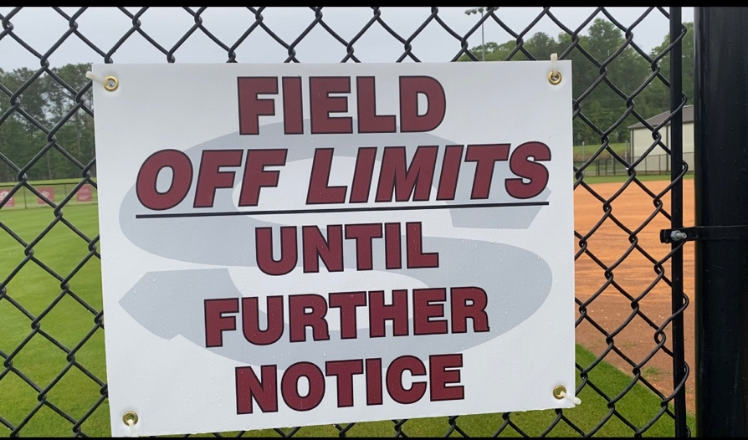
All sport facilities remain closed until further notice due to COVID-19

SYLACAUGA, Ala.- Think back on when you were in high school participating in sports. Those were probably some of the best days of your life, filled with some of your most fond memories.

Now imagine having your senior season canceled, due to the Coronavirus. Coronavirus began affecting the collegiate and professional sports world in early March and the sports world slowly began to halt and it was only a matter of time before high school sports were also affected by the pandemic. There has never been a time with more uncertainty. Athletes of this age have never experienced a crisis of this kind and prepared themselves for the worst outcome, as it was almost predictable that the remainder of baseball and softball season would be postponed or canceled, due to rapid acceleration of Coronavirus.

On March 9, the Alabama High School Athletic Association released a statement to all high school coaches stating that they were monitoring the spread of the virus and urged coaches to play all area games, as soon as possible. Coaches quickly got to work making phone calls, sending emails and rescheduling games as the future of their season was uncertain.

Fayetteville High School softball coach Leigh Holley made many changes to her schedule, to ensure her team could still compete in post season play, if sports were postponed and a contingency plan was released.

Here’s a play-by-play of the rapid changes that took place in the high school sports world told by Coach Holley:
Monday, March 9th:
● Received an email from the AHSAA letting coaches of all spring sports know that they were monitoring the COVID-19 spread. They urged us to play all of our required contests first and to be prepared for contingency playoff and postseason formats. They did not give any information about what those contingency formats may be.
● I forwarded the email on to my Athletic Director, John Limbaugh, and Principal, Amy Smith to see if they read that email the same way that I did. I felt like they were telling us to start moving games around. My principal and AD both agreed that they would ask Griff Hill, Coordinator of Athletics for all Talladega County Schools.
● After practice, I called several other coaches and we all agreed to make changes once Alabama had its first case.
Tuesday, March 10th:
● Griff Hill said that he felt like the decision to change our schedules would look different for every school and every system. Those decisions were to be left up to individual coaches.
● My concerns with making changes was that I was going to look like a crazy person for moving games when nothing was going on in our surrounding area. This wasn’t going to be an easy job and didn’t just involve moving up the area games. I would have to cancel games with non-area opponents to put the required area games in those slots. It would cause a chain reaction across the state.
● I told my principal that my plan was to monitor the situation multiple times a day and that I was prepared to make drastic changes quickly. She agreed that was the best course of action.
● Due to rain, I had to cancel our area game scheduled for this day. It was moved to Wednesday, March 18th.
Wednesday, March 11th:
● I received a phone call from John Limbaugh around 8:45PM. He was leaving a regional meeting in Jacksonville with the AHSAA. They were told in this meeting that Spring coaches needed to get things moved ASAP. I told him that I would make it happen.
Thursday, March 12th:
● I started calling coaches during my lunch break.
● Moving games caused a major ripple effect across the state. Below you will find our before and after schedule. Our area included Coosa Central, Thorsby, and Vincent.

Date | Before Change | After Change
March 12 | @ Coosa 4:30 | @ Coosa 4:30
March 13 | Talladega County Tournament | Talladega County Tournament
March 14 | Talladega County Tournament | Talladega County Tournament
March 15 | Off | Off
March 16 | Practice | Coosa @ FHS
March 17 | @Shelby County | @ Vincent
March 18 | Practice | Vincent @ FHS
March 19 | Thorsby | @ Thorsby
March 20 | Off | Thorsby @ FHS

● I quickly typed up a schedule of the changes to get us through Spring Break. I didn’t have time to make any other changes. I rescheduled buses, contacted umpires, and talked to my administration before leaving for the game at Coosa.
● I stopped my Seniors in the parking lot and explained to them what was going on. I wanted them to understand that I felt like these changes were our best chance at making them post-season eligible. They understood that it wasn’t an ideal situation but were going to give it our best effort. Their biggest concern was playing our biggest opponent of the year back-to-back days. We had not played good ball. We knew that the two games against Thorsby at the end of this long stretch was going to be difficult.
● I met with Varsity parents. I handed out new schedules and apologized for the drastic last- minute changes. They all understood and were grateful that we were trying to get games in.
● I cried on the bus ride home. How do we make this work? If we couldn’t string together some area wins, we were going to be in trouble. What was the contingency playoff format? Were they going to only take the top team from each area based off of regular season play and do away with the area tournament? If so, we had to win every game Monday-Friday the next week to keep it from going to a coin toss. Were they going to take the top two teams? If so, we could just
focus on Vincent. How do you prepare for a playoff format that you don’t know what the qualifications are to get in?
● As I was getting into my car at the school, the baseball team was playing at home. I had the strangest feeling as I stood in the parking lot. I knew something wasn’t right. The lights seemed extra bright and I felt like my time was running out. Maybe I was just emotionally spent.
Friday, March 13th:
● I met the girls at the school at 6:15AM. We were schedule to play the first game of the County Tournament at Lincoln that morning at 9:00AM.
● At 11:16AM we received an email that the Superintendent was cancelling all events that would cause a gathering of 500 or more people. Panic set in. Were they about to cancel this tournament?
● Around 1:00 we received word that the softball tournament would continue because we were only playing one game at a time on one field and our numbers had been large. We had dodged a bullet.
● At 1:55 I received a phone call from the head coach at Vincent. Shelby County Schools had cancelled all athletic activities effective immediately. Our games for Tuesday and Wednesday the next week were cancelled.
● We got the call that all schools would close on Wednesday afternoon. Monday was all we had left.
● Alabama had our first 2 positive cases of COVID-19.
● I made phone calls once I got home to John Limbaugh and my assistant coaches. Could we move Senior Night up from April 16th to Monday, March 16th?
Saturday, March 14th:
● Arrived in Lincoln at 7:30AM to warm-up for our game against Talladega Central.
● I met with Seniors and their parents. I informed them that I was moving Senior Night up. I apologized for the last-minute change. I told them that I controlled when we did Senior Night, but I couldn’t control finishing the season. They agreed that this was the best decision. Instead of spending time warming up with my team, I was on the phone. I called our booster club president to get Senior night signs. I called my principal. She couldn’t be there because she had previous engagement but understood the decision. I called a friend and ordered flowers.
Sunday, March 17th:
● My phone went off all day. Coaches calling and texting trying to get games for Monday. They were desperate. You could hear it in their voices. If I couldn’t play, did I know someone who could. They didn’t care how far they had to drive. They didn’t care if they only play one Varsity game. It was ALL DAY. I got phone calls from schools I had never played before. Schools from all across the state. I watched and read the news all day.
Monday, March 16th:
● I got up early. I didn’t sleep well and had stuff to do anyway. I got ready for work and left extra early. I needed to get some breakfast and get to the school so I could put my signs out for Senior Night. I wanted them up before the girls got on campus.
● At 6:45 my phone went off. It was a text from Amy Smith. All extra-curricular events had been cancelled in Talladega County. NO!!!!
● I quickly started calling players. My Seniors had to hear it from me before someone else called them.
● Phone call #1 was rough. I had to hold it together. I had 3 more to make.
● Phone call #2. Rougher than the first. I’m still ok. I can do this.
● Phone call #3. No answer.
● Phone call #4. I’m crying. She says thank you for everything. Thank you for believing I could play Varsity as an 8th grader. You made me better than I thought I ever could be. I had to pull my car off to the side of the road.
● Phone call #3 calls back. She knew as soon as I answered. I couldn’t get it together. She asked if we were cancelled. I just said “I’m so sorry. It wasn’t my decision.”
● I arrived at school thinking that we had 3 days to get things together before we were closed for almost 3 weeks.
● We had maybe 100 kids on campus. Checkouts were happening so fast that they just started doing all-calls for kids instead of calling each individual room. It was like Homecoming Parade day. Everyone was leaving. You could cut the tension in the air. Everyone was on edge.
● We got an email saying that we would be closing at 1:00. We were done until April 6th.
● I knew it was worse than that. We turned in e-learning plans quickly. I started packing up things that I may need to teach from home. I grabbed some white boards, markers, a webcam, some teacher text books and my pacing guides. I started loading things in my car. I was just being cautious. We were coming back. Maybe not April 6th but at some point.
Thursday, March 26th:
● I was nervous all day. I knew deep down what was coming in that press conference that was scheduled. We were done with school for the year. We wouldn’t be going back to campus. The number of cases were growing too fast. They were bringing in refrigerated trucks in NYC for the dead bodies. We weren’t putting kids back in the classroom. I had talked to my Senior players a few times over the break. They had so many questions that I couldn’t answer.
● Press Conference: Athletics were over.

“Seniors, I hope you know how much you were loved,” said Holley.” I hope you know how hard I tried. We have always talked about legacies, stories and impacts on our program that each athlete and class have. I have pushed you since the end of your junior year to really start making sure that your story was what you had always dreamed it would be. I promise you that your story will always be told. You have the story of sacrifice. No senior athletes will ever sacrifice more for the greater good of humanity than you have.”

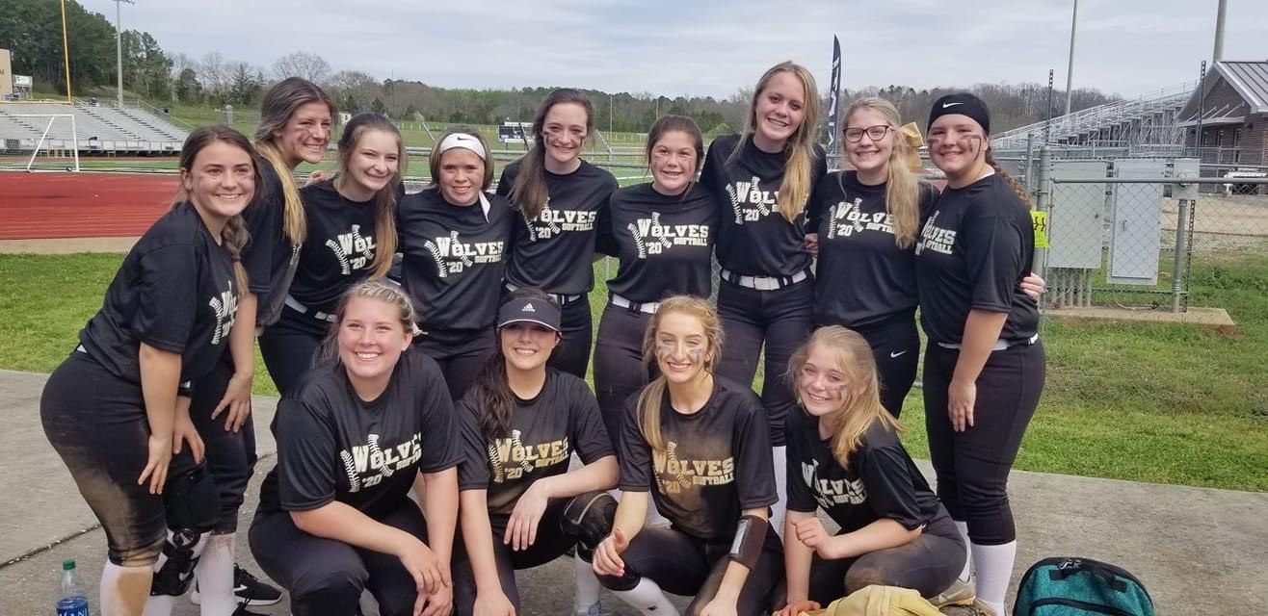
The Fayetteville High School Lady Wolves Softball team at the 2020 Talladega County Softball Tournament.

Softball wasn’t the only spring sport that was hit hard by the rapid changes that led to the cancellation of the rest of the 2020 season. The Sylacauga Aggies Baseball team battled both the pandemic and Alabama weather, making it difficult to finish playing the required games before schools were closed.

The Aggies remained hopeful that they would get to finish their season at a later time, however like softball the remainder of their season was canceled. While some seniors plan to continue playing at the next level, most are left with memories, as they walked off the field and hung up their jerseys for the last time.

“I really thought we’d be postponed for a couple of weeks,” said Aggies head baseball coach Jeff Bell. “Things happen in life that we can’t control, how we deal with those things determines our happiness. Hopefully this high school baseball experience has prepared them to be able to handle adversity that comes along in life.”

This senior class is left with many what ifs. What if the coronavirus didn’t happen? What if we could have finished the regular season? What if we would have made the playoffs? What if we got to have a senior night? These are all things that the class of 2020 will never get their answers to or get to experience. Most senior athletes hope their season ends in a state championship, not a global pandemic.

The class of 2020 has endured more adversity in a single season than any other senior class.

“You will never know when your last at-bat is, last time on the mound, last pregame tape wrap, last intersquad, last moment on the diamond will be,” said Sylacauga senior Cole Porch. “Make as many memories at possible and make every appearance count because in the end, all we have left is memories.”

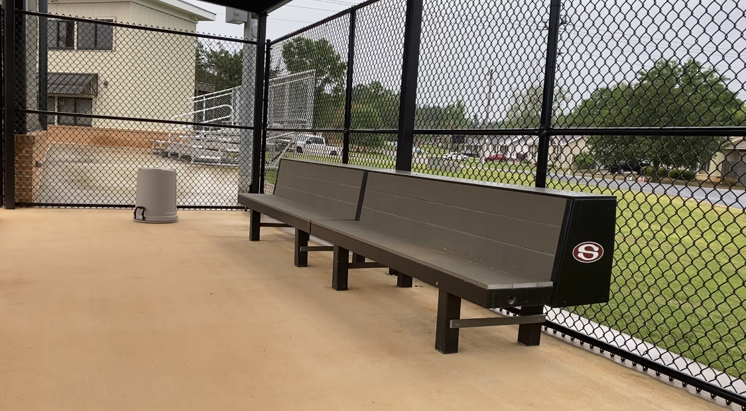
Dugouts across the nation remain empty as the remainder of the 2020 high school season was canceled.

Class of 2020, your legacy and story will never be forgotten. Although your senior year may not have ended the way it should have, keep your heads held high and remember this is only a bump in the road and not a final destination.

